**Title: To understand and use SQL Sub-Query**

**Objective:** To understand the use of sql subquery.

**1. Create the following table.**

Supplier-(scode,sname,scity,turnover)

Part-(pcode,weigh,color,cost,sellingprice)

Supplier_Part-(scode,pcode,qty)

I/O-

USE DBMS;

CREATE TABLE Supplier(

SCODE INT PRIMARY KEY,

SNAME VARCHAR(30),

SCITY VARCHAR(30),

TURNOVER DECIMAL(10,3)

);

CREATE TABLE PART(

PCODE INT PRIMARY KEY,

WEIGH NUMERIC,

COLOR VARCHAR(10),

COST NUMERIC,

SELLPRICE NUMERIC

);

CREATE TABLE SupplierPart (

SCODE INT,

PCODE INT,

QTY INT,

PRIMARY KEY(SCODE,PCODE),

foreign key (SCODE) REFERENCES SUPPLIER(SCODE),

foreign key (PCODE) REFERENCES PART(PCODE)

);

**2. Populate the table**

INSERT INTO Supplier

VALUES

(1, "Ishita","Doon",100.00),

(2, "Sarthak","Saharanpur",120.00),

(3, "Sam","Kanpur",130.00),

(4, "Rudy","Gurugram",60.00),

(5, "Akash","Ayodhaya",70.00),

(6,"Prerna","Doon",100.00),

(7,'Aman', 'Mumbai',100.00 ),

(8,'Omkar', 'Mumbai',40.00 ),

(9,'Raj', 'Mumbai',120.00 ),

(10,'Ashish',"Delhi",300.00);

insert into PART VALUES

(500123,20,"Black",300.00,4300.00),

(500124,24,"Blue",200.00,2500.00),

(500125,45,"Brown",3005.00,4000.00),

(500126,34,"Peach",1200.00,1500.00),

(500127,68,"Pink",4000.00,5000.00),

(500183,45,"Burgendi",3400.00,4500.00);

INSERT INTO SUPPLIERPART VALUES

(1,500123,24),

(1,500124,34),

(2,500126,58),

(3,500125,2),

(10,500127,76),

(5,500183,34),

(4,500183,87),

(6,500124,120),

(8,500127,35),

(7,500125,10),

(9,500183,23),

(6,500127,65);

Select * from supplier;

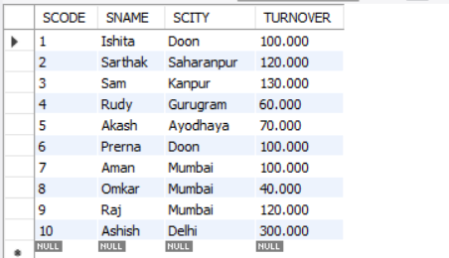

Select * from part;

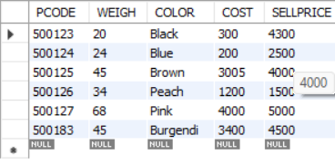

Select * from supplierpart;

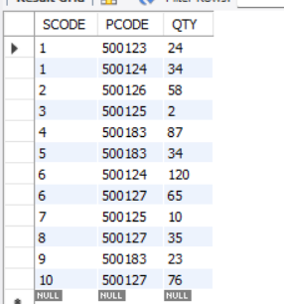

**3. Write appropriate SQL Statement for the following:**

-- Get the supplier number and part number in ascending order of supplier number.

SELECT SCODE,PCODE FROM SUPPLIERPART ORDER BY SCODE ASC;

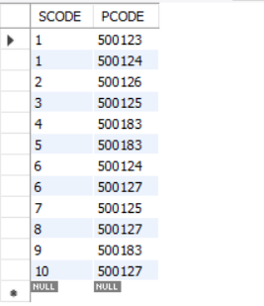

-- Get the details of supplier who operate from Bombay/Mumbai with turnover 120.

SELECT * FROM SUPPLIER WHERE SCITY="Mumbai" and TURNOVER=120;

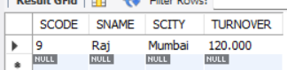

-- Get the total number of supplier.

SELECT COUNT(SCODE) FROM SUPPLIER ;

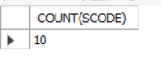

-- Get the part number weighing between 25 and 35.

SELECT PCODE FROM PART WHERE WEIGH BETWEEN 25 AND 35;

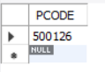

-- Get the supplier number whose turnover is null.

SELECT SCODE FROM SUPPLIER WHERE TURNOVER IS NULL; -- IS NULL IS CORRECT AND NOT =NULL



-- Get the part number that cost 20, 30 or 40 rupees.

SELECT PCODE FROM PART WHERE COST=200 OR 300 OR 400; -- USE IN(200,300,400)

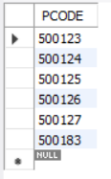

-- Get the total quantity of part 500124 that is supplied.

SELECT SUM(QTY) FROM SUPPLIERPART WHERE PCODE=500124 ;

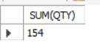

-- Get the name of supplier who supply part 500124

SELECT SNAME FROM SUPPLIER WHERE SCODE IN (SELECT SCODE FROM SUPPLIERPART WHERE PCODE = 500124);-- NESTED QUERIES

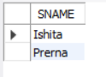

-- Get the part number whose cost is greater than the average cost.

SELECT PCODE FROM PART WHERE COST > (SELECT AVG(COST) FROM PART);

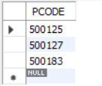

-- Get the supplier number and turnover in descending order of turnover.

SELECT SCODE,TURNOVER FROM SUPPLIER ORDER BY TURNOVER DESC;

